

*Train with Certified Spartan SGX Coach and RRCA Certified Running Coach, Christy Scott*

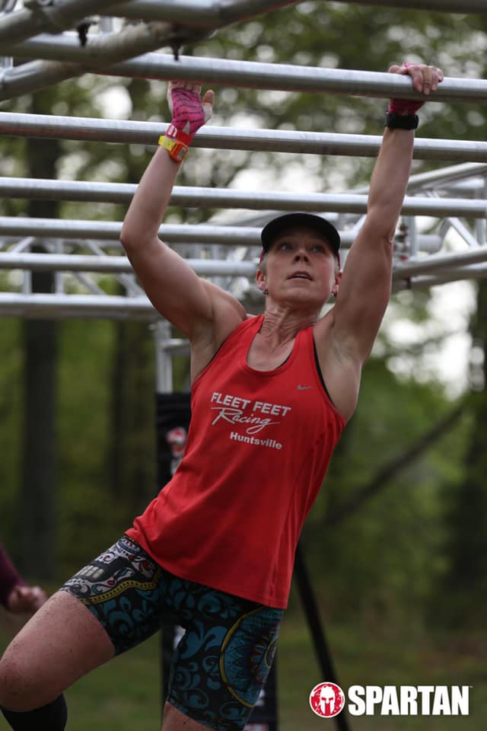

Training begins July 28, 2019

**Goal race**: Spartan Nashville Sprint/Super, October 20, 2019

What do you get:

* Twelve weekly 60 minute in-person sessions in a small group setting (max of 12 people) with a Spartan SGX Certified Coach
* A 12-week proven plan to get you to the start line prepared to kick butt
* A 12-week running plan to build endurance, speed and prepare you to handle the Spartan race course
* Private Facebook group where I will share tips, video demos, motivation, and provide on-going support and nutritional guidance customized for you
* Three bonus “field trips” to work on obstacles with me, build teamwork, and create confidence
* A program to help develop flexibility, mobility and grip strength
* A how to prep for race day roadmap so that your check list is done for you
* Insider tips to conquer the obstacles you will face on race day
* Periodic fitness assessments so that you know what you need to work on the most
* A group of crazy friends as insane as you to tackily race day with!
* Other surprise “bonuses” throughout the program! ☺

**Weekly sessions will take place on Mondays at 5:30 PM at Sweatlocal in Jones Valley. Cost is only $250 for all of the above!

Space is limited to 12 participants to ensure lots of personal attention! Don’t miss out!

Interested? Get your application here:

[www.fitnessonthemovellc.com](http://www.fitnessonthemovellc.com)

Contact Christy Scott at [fitnessonthemove@gmail.com](mailto:fitnessonthemove@gmail.com) or call 256-508-1925.